**Code: -**

1. **Loading Page (Form1): -**

**Components Used:** Panel, Progress Bar, Picture Box, Label, Timer

Public Class Form1

Private Sub Timer1_Tick(sender As Object, e As EventArgs) Handles Timer1.Tick

ProgressBar1.Increment(6)

Label4.Text = ProgressBar1.Value & "%"

If ProgressBar1.Value = 100 Then

Timer1.Stop()

Form2.Show()

Me.Hide()

End If

End Sub

Private Sub Form1_Load(sender As Object, e As EventArgs) Handles MyBase.Load

Timer1.Start()

End Sub

End Class

1. **HMS Home Page (Form2): -**

**Components Used:** Panel, Picture Box, Label

Public Class Form2

Private Sub PictureBox6_Click(sender As Object, e As EventArgs) Handles PictureBox6.Click

Form3.Show()

Me.Hide()

End Sub

Private Sub Label6_Click(sender As Object, e As EventArgs) Handles Label6.Click

Form3.Show()

Me.Hide()

End Sub

Private Sub PictureBox7_Click(sender As Object, e As EventArgs) Handles PictureBox7.Click

Form4.Show()

Me.Hide()

End Sub

Private Sub Label7_Click(sender As Object, e As EventArgs) Handles Label7.Click

Form4.Show()

Me.Hide()

End Sub

Private Sub PictureBox9_Click(sender As Object, e As EventArgs) Handles PictureBox9.Click

Form5.Show()

Me.Hide()

End Sub

Private Sub Label8_Click(sender As Object, e As EventArgs) Handles Label8.Click

Form5.Show()

Me.Hide()

End Sub

Private Sub PictureBox11_Click(sender As Object, e As EventArgs) Handles PictureBox11.Click

Form6.Show()

Me.Hide()

End Sub

Private Sub Label9_Click(sender As Object, e As EventArgs) Handles Label9.Click

Form6.Show()

Me.Hide()

End Sub

Private Sub PictureBox2_Click(sender As Object, e As EventArgs) Handles PictureBox2.Click

End Sub

End Class

1. **Student Login Page (Form 3): -**

**Components Used:** Panel, Picture Box, Label, textbox, button

Public Class Form3

Private Sub LinkLabel2_LinkClicked(sender As Object, e As LinkLabelLinkClickedEventArgs) Handles LinkLabel2.LinkClicked

'When click on register'

Form7.Show()

Me.Hide()

End Sub

Private Sub PictureBox6_Click(sender As Object, e As EventArgs) Handles PictureBox6.Click

'when click on left arrow'

Form2.Show()

Me.Hide()

End Sub

Private Sub Form3_Load(sender As Object, e As EventArgs) Handles MyBase.Load

End Sub

Private Sub TextBox1_TextChanged(sender As Object, e As EventArgs) Handles TextBox1.TextChanged

End Sub

Private Sub Button1_Click(sender As Object, e As EventArgs) Handles Button1.Click

If GUI__APPLICATION.Form7.RadioButton1.Checked Then

If TextBox1.Text = GUI__APPLICATION.Form7.inc And TextBox2.Text = GUI__APPLICATION.Form7.TextBox8.Text Then

MsgBox("Welcome!")

Else

MsgBox("Wrong Credentials!")

End If

ElseIf GUI__APPLICATION.Form7.RadioButton2.Checked Then

If TextBox1.Text = GUI__APPLICATION.Form7.inc And TextBox2.Text = GUI__APPLICATION.Form7.TextBox8.Text Then

MsgBox("Wrong Credentials!")

Else

MsgBox("Wrong Credentials!")

End If

ElseIf GUI__APPLICATION.Form7.RadioButton3.Checked Then

If TextBox1.Text = GUI__APPLICATION.Form7.inc And TextBox2.Text = GUI__APPLICATION.Form7.TextBox8.Text Then

MsgBox("Wrong Credentials!")

Else

MsgBox("Wrong Credentials!")

End If

ElseIf GUI__APPLICATION.Form7.RadioButton4.Checked Then

If TextBox1.Text = GUI__APPLICATION.Form7.inc And TextBox2.Text = GUI__APPLICATION.Form7.TextBox8.Text Then

MsgBox("Wrong Credentials!")

Else

MsgBox("Wrong Credentials!")

End If

End If

End Sub

End Class

1. **Admin Login Page (Form 4): -**

**Components Used:** Panel, Picture Box, Label, textbox, button

Public Class Form4

Private Sub LinkLabel2_LinkClicked(sender As Object, e As LinkLabelLinkClickedEventArgs) Handles LinkLabel2.LinkClicked

'when click on register'

Form7.Show()

Me.Hide()

End Sub

Private Sub PictureBox6_Click(sender As Object, e As EventArgs) Handles PictureBox6.Click

'when click on left arrow'

Form2.Show()

Me.Hide()

End Sub

Private Sub Button1_Click(sender As Object, e As EventArgs) Handles Button1.Click

If GUI__APPLICATION.Form7.RadioButton1.Checked Then

If TextBox1.Text = GUI__APPLICATION.Form7.inc And TextBox2.Text = GUI__APPLICATION.Form7.TextBox8.Text Then

MsgBox("Wrong Credentials!")

Else

MsgBox("Wrong Credentials!")

End If

ElseIf GUI__APPLICATION.Form7.RadioButton2.Checked Then

If TextBox1.Text = GUI__APPLICATION.Form7.inc And TextBox2.Text = GUI__APPLICATION.Form7.TextBox8.Text Then

MsgBox("Welcome!")

Else

MsgBox("Wrong Credentials!")

End If

ElseIf GUI__APPLICATION.Form7.RadioButton3.Checked Then

If TextBox1.Text = GUI__APPLICATION.Form7.inc And TextBox2.Text = GUI__APPLICATION.Form7.TextBox8.Text Then

MsgBox("Wrong Credentials!")

Else

MsgBox("Wrong Credentials!")

End If

ElseIf GUI__APPLICATION.Form7.RadioButton4.Checked Then

If TextBox1.Text = GUI__APPLICATION.Form7.inc And TextBox2.Text = GUI__APPLICATION.Form7.TextBox8.Text Then

MsgBox("Wrong Credentials!")

Else

MsgBox("Wrong Credentials!")

End If

End If

End Sub

End Class

1. **Mess Admin Login Page (Form 5): -**

**Components Used:** Panel, Picture Box, Label, textbox, button

Public Class Form5

Private Sub LinkLabel2_LinkClicked(sender As Object, e As LinkLabelLinkClickedEventArgs) Handles LinkLabel2.LinkClicked

'when click on register'

Form7.Show()

Me.Hide()

End Sub

Private Sub PictureBox6_Click(sender As Object, e As EventArgs) Handles PictureBox6.Click

'when click on left arrow'

Form2.Show()

Me.Hide()

End Sub

Private Sub Button1_Click(sender As Object, e As EventArgs) Handles Button1.Click

If GUI__APPLICATION.Form7.RadioButton1.Checked Then

If TextBox1.Text = GUI__APPLICATION.Form7.inc And TextBox2.Text = GUI__APPLICATION.Form7.TextBox8.Text Then

MsgBox("Wrong Credentials!")

Else

MsgBox("Wrong Credentials!")

End If

ElseIf GUI__APPLICATION.Form7.RadioButton2.Checked Then

If TextBox1.Text = GUI__APPLICATION.Form7.inc And TextBox2.Text = GUI__APPLICATION.Form7.TextBox8.Text Then

MsgBox("Wrong Credentials!")

Else

MsgBox("Wrong Credentials!")

End If

ElseIf GUI__APPLICATION.Form7.RadioButton3.Checked Then

If TextBox1.Text = GUI__APPLICATION.Form7.inc And TextBox2.Text = GUI__APPLICATION.Form7.TextBox8.Text Then

MsgBox("Welcome!")

Else

MsgBox("Wrong Credentials!")

End If

ElseIf GUI__APPLICATION.Form7.RadioButton4.Checked Then

If TextBox1.Text = GUI__APPLICATION.Form7.inc And TextBox2.Text = GUI__APPLICATION.Form7.TextBox8.Text Then

MsgBox("Wrong Credentials!")

Else

MsgBox("Wrong Credentials!")

End If

End If

End Sub

End Class

1. **Security Guard Login Page (Form 6): -**

**Components Used:** Panel, Picture Box, Label, textbox, button

Public Class Form6

Private Sub LinkLabel2_LinkClicked(sender As Object, e As LinkLabelLinkClickedEventArgs) Handles LinkLabel2.LinkClicked

'when click on register'

Form7.Show()

Me.Hide()

End Sub

Private Sub PictureBox6_Click(sender As Object, e As EventArgs) Handles PictureBox6.Click

'when click on left arrow'

Form2.Show()

Me.Hide()

End Sub

Private Sub Button1_Click(sender As Object, e As EventArgs) Handles Button1.Click

If GUI__APPLICATION.Form7.RadioButton1.Checked Then

If TextBox1.Text = GUI__APPLICATION.Form7.inc And TextBox2.Text = GUI__APPLICATION.Form7.TextBox8.Text Then

MsgBox("Wrong Credentials!")

Else

MsgBox("Wrong Credentials!")

End If

ElseIf GUI__APPLICATION.Form7.RadioButton2.Checked Then

If TextBox1.Text = GUI__APPLICATION.Form7.inc And TextBox2.Text = GUI__APPLICATION.Form7.TextBox8.Text Then

MsgBox("Wrong Credentials!")

Else

MsgBox("Wrong Credentials!")

End If

ElseIf GUI__APPLICATION.Form7.RadioButton3.Checked Then

If TextBox1.Text = GUI__APPLICATION.Form7.inc And TextBox2.Text = GUI__APPLICATION.Form7.TextBox8.Text Then

MsgBox("Wrong Credentials!")

Else

MsgBox("Wrong Credentials!")

End If

ElseIf GUI__APPLICATION.Form7.RadioButton4.Checked Then

If TextBox1.Text = GUI__APPLICATION.Form7.inc And TextBox2.Text = GUI__APPLICATION.Form7.TextBox8.Text Then

MsgBox("Welcome!")

Else

MsgBox("Wrong Credentials!")

End If

End If

End Sub

End Class

1. **HMS Registration Page (Form 7): -**

**Components Used:** Panel, Picture Box, Label, textbox, button, error provider, checkbox, radio button, Rich Textbox, Open Dialog Box

Imports System.Text.RegularExpressions

Public Class Form7

Public inc As Integer = 1201

Dim First As String = "^[A-Z][a-z]{1,40}$"

Dim Middle As String = "^[A-Z][a-z]{1,40}$"

Dim Last As String = "^[A-Z][a-z]{1,40}$"

Dim num As String = "^[987][0-9]{9}$"

Dim otp As String = "^[0-9]{4}$"

Dim email As String = "^[a-z 0-9\.]{5,40}@[a-z]{5,12}\.[a-z]{2,3}$"

Dim pass As String = "^(?=.*[A-Z])(?=.*[a-z])(?=.*\d)(?=.*[@#$])[A-Za-z\d@#$]{8}$"

Dim i As Integer = 0

Private Sub ValidateInputsAndShowMessageBox()

' Check if PictureBox6 has no image

If PictureBox6.Image Is Nothing Then

MessageBox.Show("Please select Passport Image.", "Error", MessageBoxButtons.OK, MessageBoxIcon.Error)

Return

End If

' Check if any radio button is not selected

If Not (RadioButton1.Checked Or RadioButton2.Checked Or RadioButton3.Checked Or RadioButton4.Checked) Then

MessageBox.Show("Please select Role", "Error", MessageBoxButtons.OK, MessageBoxIcon.Error)

Return

End If

' Check if CheckBox1 is not checked

If Not CheckBox1.Checked Then

MessageBox.Show("Please Accept Conditions", "Error", MessageBoxButtons.OK, MessageBoxIcon.Error)

Return

End If

' Check if ErrorProvider controls have no errors

If Not (String.IsNullOrEmpty(ErrorProvider1.GetError(PictureBox6)) AndAlso

String.IsNullOrEmpty(ErrorProvider2.GetError(RadioButton1)) AndAlso

String.IsNullOrEmpty(ErrorProvider3.GetError(CheckBox1))) Then

MessageBox.Show("Please correct the errors.", "Error", MessageBoxButtons.OK, MessageBoxIcon.Error)

Return

End If

' If all conditions are met, navigate to the next form

Form8.Show()

Me.Hide()

End Sub

Private Sub Button4_Click(sender As Object, e As EventArgs) Handles Button4.Click

OpenFileDialog1.Title = "Select Profile Photo"

OpenFileDialog1.Filter = "JPEG Files (*.jpg, *.jpeg)|*.jpg;*.jpeg|All Files (*.*)|*.*"

Dim picture As String

If OpenFileDialog1.ShowDialog = DialogResult.OK Then

picture = OpenFileDialog1.FileName

PictureBox6.Image = Image.FromFile(picture)

End If

End Sub

Private Sub Button3_Click(sender As Object, e As EventArgs) Handles Button3.Click

ValidateInputsAndShowMessageBox()

Dim passcode As String = TextBox7.Text

End Sub

Private Sub TextBox1_Leave(sender As Object, e As EventArgs) Handles TextBox1.Leave

If Regex.IsMatch(TextBox1.Text, First) = False Then

ErrorProvider1.SetError(TextBox1, "Must contain alphabetic characters only. First letter should be capitalized. Ex. Om ")

TextBox1.Focus()

TextBox1.Clear()

Else

ErrorProvider1.Clear()

End If

End Sub

Private Sub TextBox2_Leave(sender As Object, e As EventArgs) Handles TextBox2.Leave

If Regex.IsMatch(TextBox2.Text, Middle) = False Then

ErrorProvider2.SetError(TextBox2, "Must contain alphabetic characters only. Only the first letter should be capitalized. Ex. Vijay")

TextBox2.Focus()

TextBox2.Clear()

Else

ErrorProvider2.Clear()

End If

End Sub

Private Sub TextBox3_Leave(sender As Object, e As EventArgs) Handles TextBox3.Leave

If Regex.IsMatch(TextBox3.Text, Last) = False Then

ErrorProvider3.SetError(TextBox3, "Must contain alphabetic characters only. First letter should be capitalized. Ex.Mundlik")

TextBox3.Focus()

TextBox3.Clear()

Else

ErrorProvider3.Clear()

End If

End Sub

Private Sub TextBox4_Leave(sender As Object, e As EventArgs) Handles TextBox4.Leave

If Regex.IsMatch(TextBox4.Text, num) = False Then

ErrorProvider4.SetError(TextBox4, "Must consist of 10 digits. Only numerical characters allowed. Ex. 9860683310")

TextBox4.Focus()

TextBox4.Clear()

Else

ErrorProvider4.Clear()

End If

End Sub

Private Sub TextBox5_Leave(sender As Object, e As EventArgs) Handles TextBox5.Leave

If Regex.IsMatch(TextBox5.Text, otp) = False Then

ErrorProvider5.SetError(TextBox5, "Enter Valid OTP !")

TextBox5.Focus()

TextBox5.Clear()

Else

ErrorProvider5.Clear()

End If

End Sub

Private Sub TextBox7_Leave(sender As Object, e As EventArgs) Handles TextBox7.Leave

If Regex.IsMatch(TextBox7.Text, email) = False Then

ErrorProvider6.SetError(TextBox7, "Must follow standard email format: username@domain.co Ex. ommundlik31@gmail.com !")

TextBox7.Focus()

TextBox7.Clear()

Else

ErrorProvider6.Clear()

End If

End Sub

Private Sub TextBox6_Leave(sender As Object, e As EventArgs) Handles TextBox6.Leave

If Regex.IsMatch(TextBox6.Text, otp) = False Then

ErrorProvider7.SetError(TextBox6, "Enter Valid OTP !")

TextBox6.Focus()

TextBox6.Clear()

Else

ErrorProvider7.Clear()

End If

End Sub

Private Sub TextBox9_Leave(sender As Object, e As EventArgs) Handles TextBox9.Leave

If Regex.IsMatch(TextBox9.Text, pass) = False Then

ErrorProvider8.SetError(TextBox9, "Must be 8 characters long. Must contain at least one uppercase letter, one lowercase letter, and one of the following symbols: @, #, $. Example: Omi@1234 ")

TextBox9.Focus()

TextBox9.Clear()

Else

ErrorProvider8.Clear()

End If

End Sub

Private Sub TextBox8_Leave(sender As Object, e As EventArgs) Handles TextBox8.Leave

If TextBox8.Text <> TextBox9.Text Then

ErrorProvider9.SetError(TextBox8, "Must be 8 characters long. Must contain at least one uppercase letter, one lowercase letter, and one of the following symbols: @, #, $. Example: Omi@1234 ")

TextBox8.Focus()

TextBox8.Clear()

Else

ErrorProvider9.Clear()

End If

End Sub

Private Sub PictureBox5_Click(sender As Object, e As EventArgs) Handles PictureBox5.Click

End Sub

Private Sub CheckBox2_CheckedChanged(sender As Object, e As EventArgs) Handles CheckBox2.CheckedChanged

If CheckBox2.Checked = True Then

TextBox9.PasswordChar = ""

Else TextBox9.PasswordChar = "*"

End If

End Sub

Private Sub Button1_Click(sender As Object, e As EventArgs) Handles Button1.Click

Button1.Text = "Verify OTP"

TextBox5.Text = "2345"

TextBox5.BackColor = Color.LightGreen

End Sub

Private Sub Button2_Click(sender As Object, e As EventArgs) Handles Button2.Click

Button2.Text = "Verify OTP"

TextBox6.Text = "5678"

TextBox6.BackColor = Color.LightGreen

End Sub

Private Sub Form7_Load(sender As Object, e As EventArgs) Handles MyBase.Load

End Sub

End Class

1. **Registration Success Page (Form 8): -**

**Components Used:** Panel, Picture Box, Label, button

Public Class Form8

Private Sub Form8_Load(sender As Object, e As EventArgs) Handles MyBase.Load

GUI__APPLICATION.Form7.inc = GUI__APPLICATION.Form7.inc + 1

If GUI__APPLICATION.Form7.RadioButton1.Checked Then

Label5.Text = "Dear " + GUI__APPLICATION.Form7.TextBox1.Text + " " + GUI__APPLICATION.Form7.TextBox2.Text + " " + GUI__APPLICATION.Form7.TextBox3.Text + ","

Label6.Text = "Your Student Id Is " & GUI__APPLICATION.Form7.inc

Label7.Text = "Your Student Default Pass Is " + GUI__APPLICATION.Form7.TextBox9.Text

ElseIf GUI__APPLICATION.Form7.RadioButton2.Checked Then

Label5.Text = "Dear " + GUI__APPLICATION.Form7.TextBox1.Text + " " + GUI__APPLICATION.Form7.TextBox2.Text + " " + GUI__APPLICATION.Form7.TextBox3.Text + ","

Label6.Text = "Your Admin Id Is " & GUI__APPLICATION.Form7.inc

Label7.Text = "Your Admin Default Pass Is " + GUI__APPLICATION.Form7.TextBox9.Text

ElseIf GUI__APPLICATION.Form7.RadioButton3.Checked Then

Label5.Text = "Dear " + GUI__APPLICATION.Form7.TextBox1.Text + " " + GUI__APPLICATION.Form7.TextBox2.Text + " " + GUI__APPLICATION.Form7.TextBox3.Text + ","

Label6.Text = "Your Mess Admin Id Is " & GUI__APPLICATION.Form7.inc

Label7.Text = "Your Mess Admin Default Pass Is " + GUI__APPLICATION.Form7.TextBox9.Text

ElseIf GUI__APPLICATION.Form7.RadioButton4.Checked Then

Label5.Text = "Dear " + GUI__APPLICATION.Form7.TextBox1.Text + " " + GUI__APPLICATION.Form7.TextBox2.Text + " " + GUI__APPLICATION.Form7.TextBox3.Text + ","

Label6.Text = "Your Security Guard Id Is " & GUI__APPLICATION.Form7.inc

Label7.Text = "Your Security Guard Pass Is " + GUI__APPLICATION.Form7.TextBox9.Text

End If

End Sub

Private Sub PictureBox1_Click(sender As Object, e As EventArgs) Handles PictureBox1.Click

End Sub

Private Sub PictureBox6_Click(sender As Object, e As EventArgs) Handles PictureBox6.Click

Form7.Show()

Me.Hide()

End Sub

Private Sub Button1_Click(sender As Object, e As EventArgs) Handles Button1.Click

Form2.Show()

Me.Hide()

End Sub

End Class

**Output: -**

.exe Application

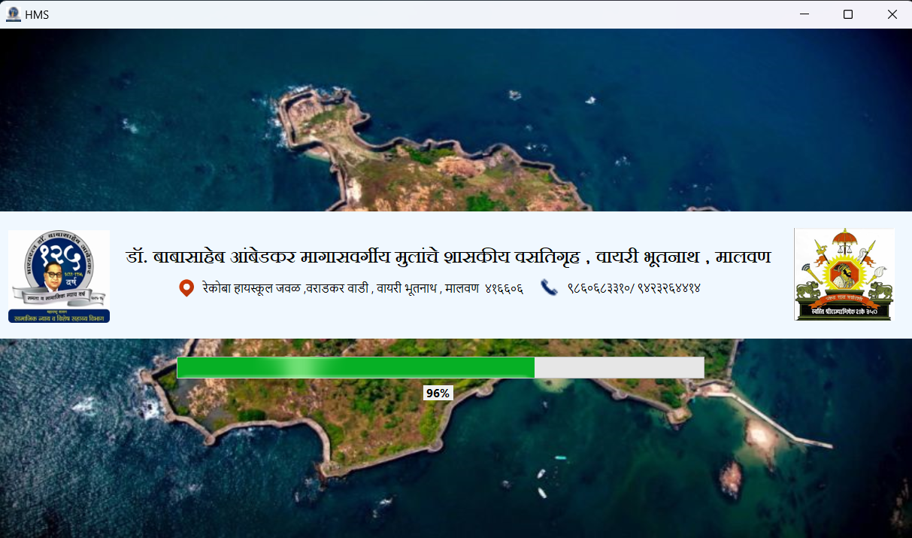 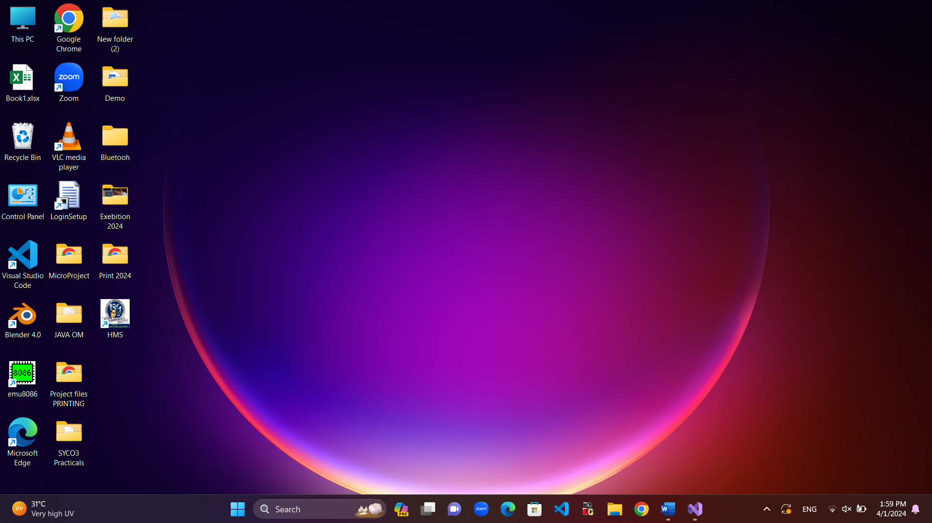

1.2 Loading Page

1.1 Application .exe File

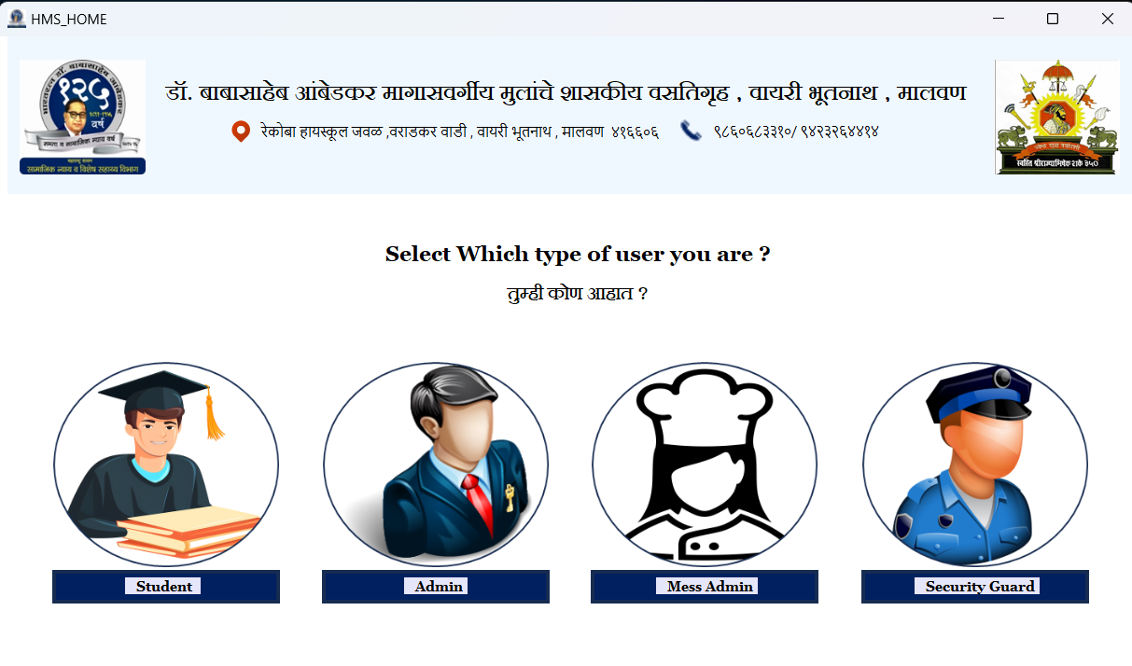

1.3 HMS Home Page

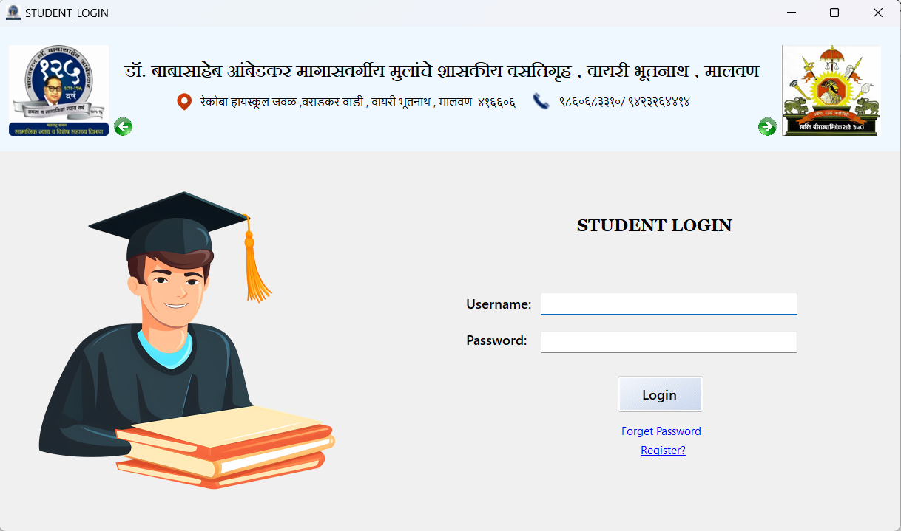

1.4 Student Login Page

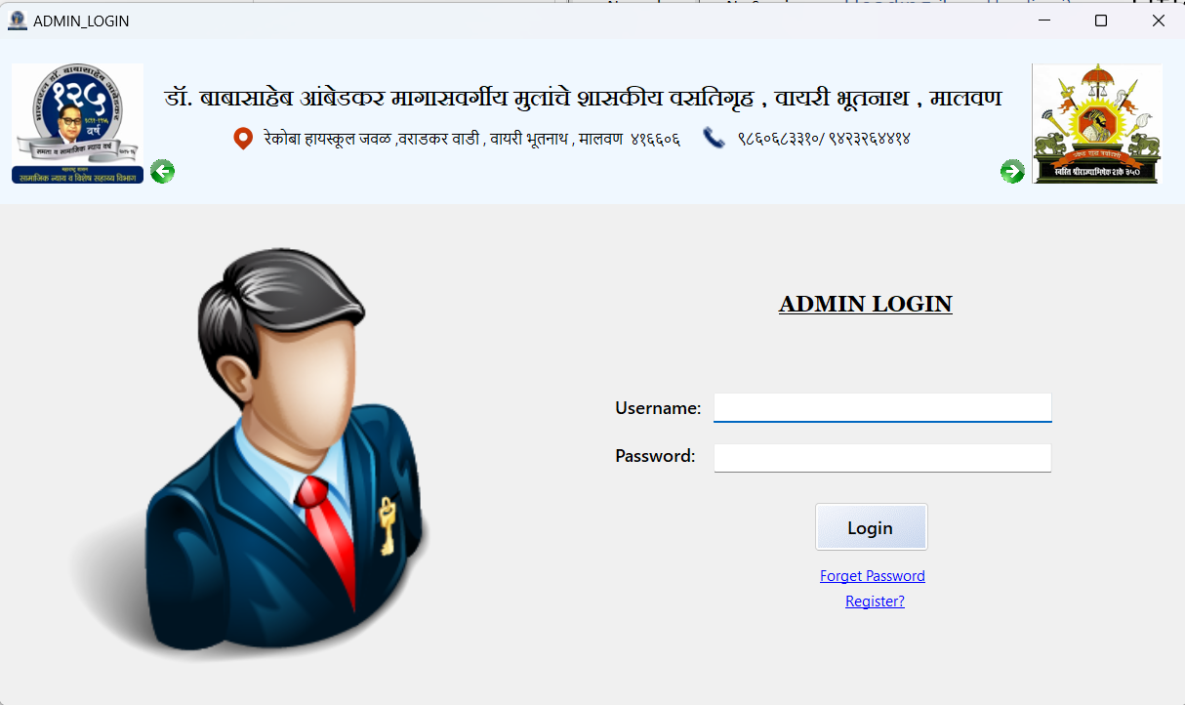

1.5 Admin Login Page

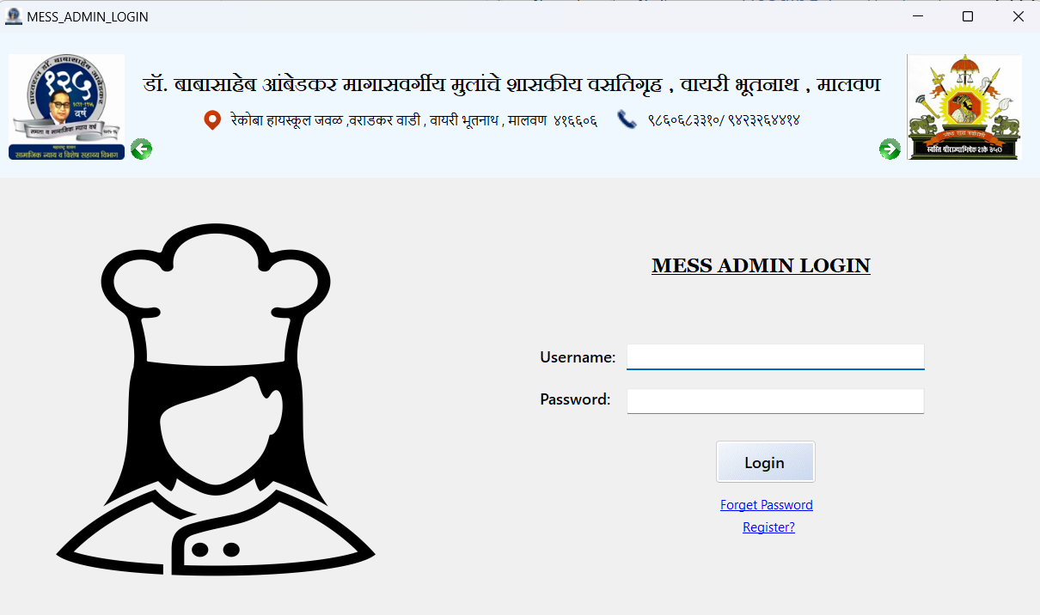

1.6 Mess Admin Login Page

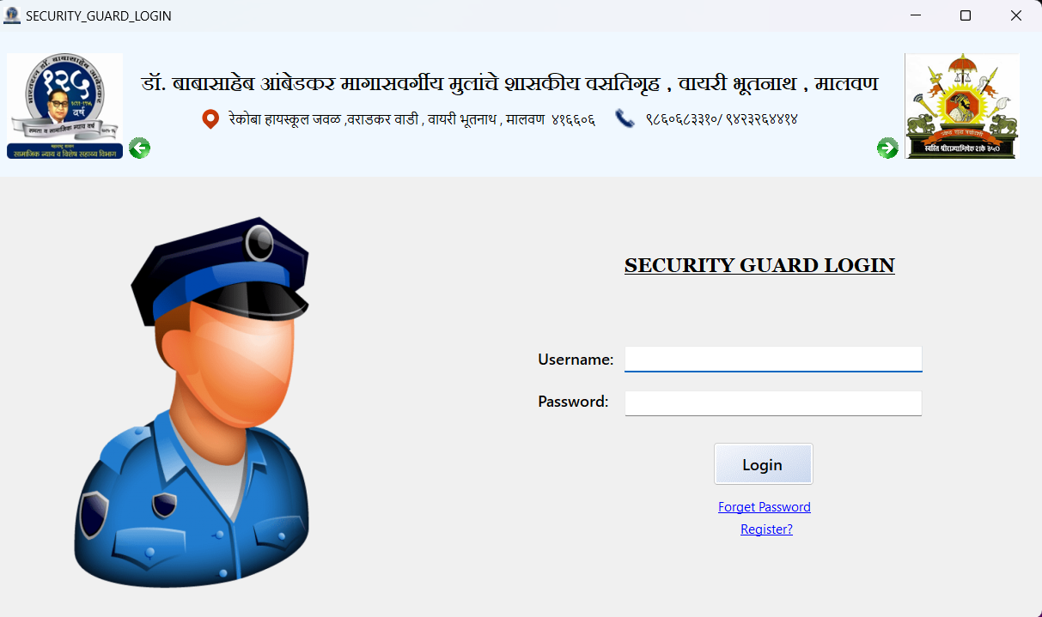

1.7 Security Guard Login Page

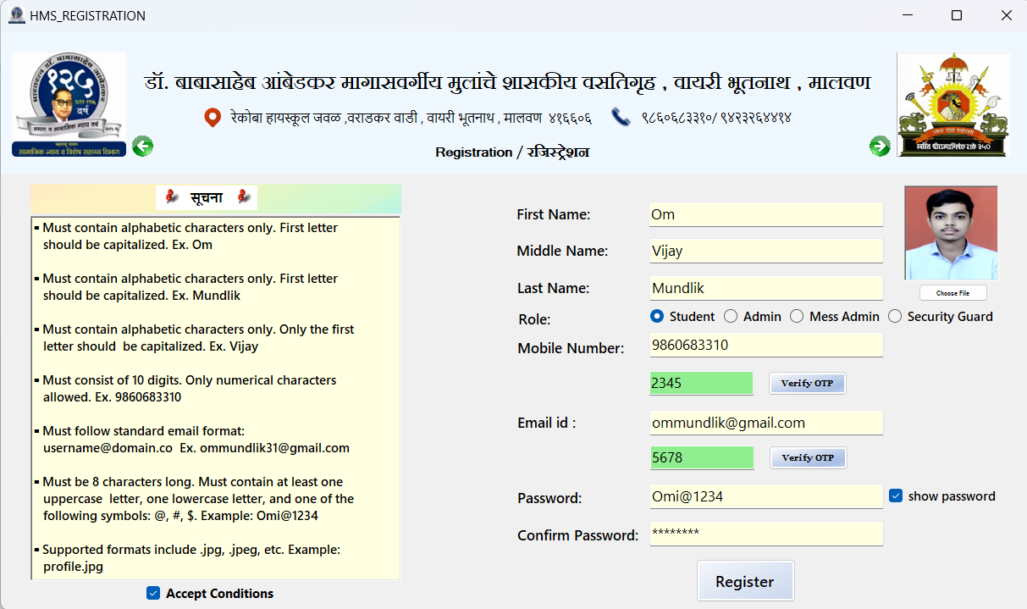

1.8 HMS Registration Page

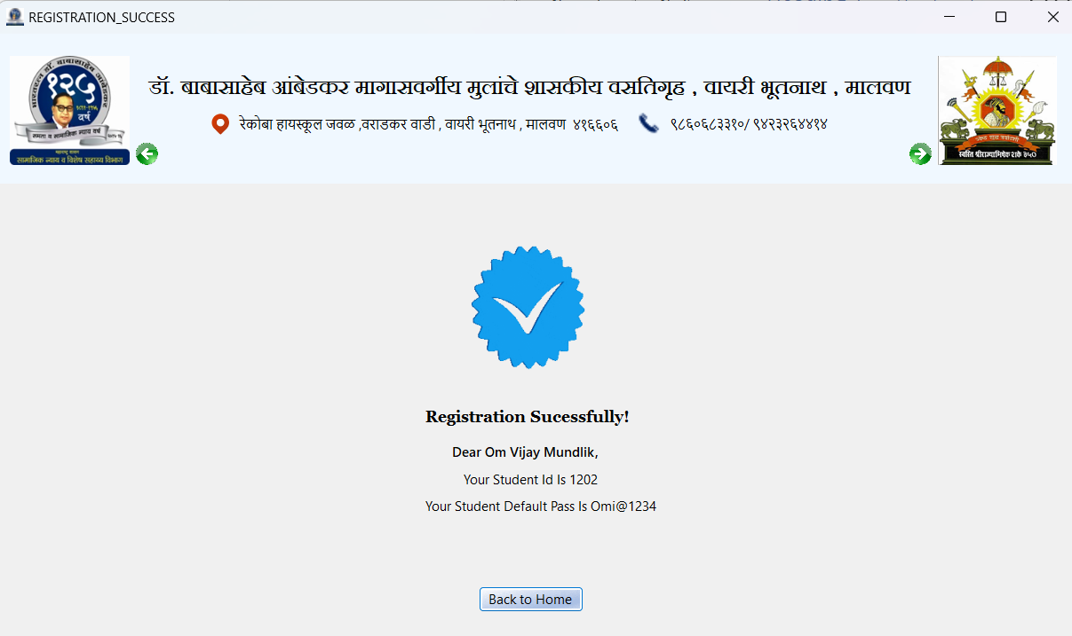

1.9 Registration Success Page

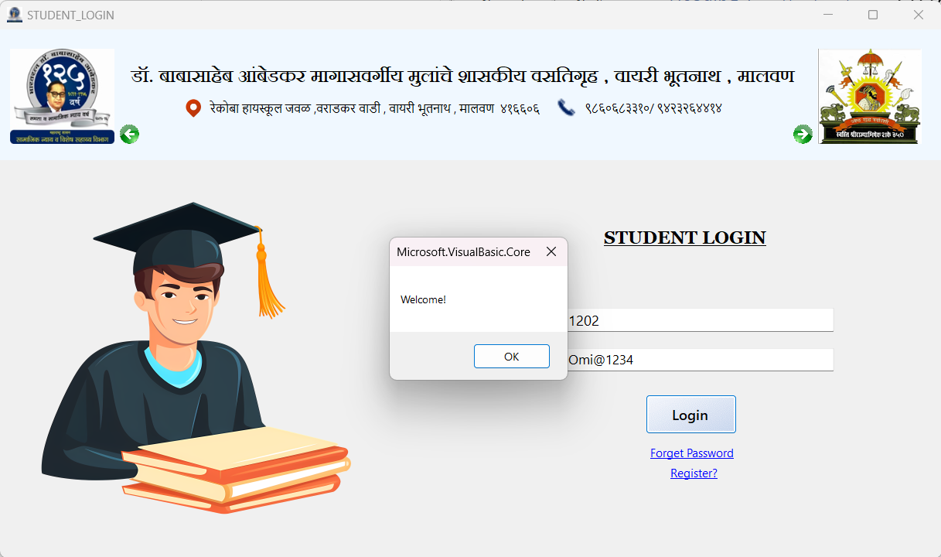

2.0 Login with Correct Credentials

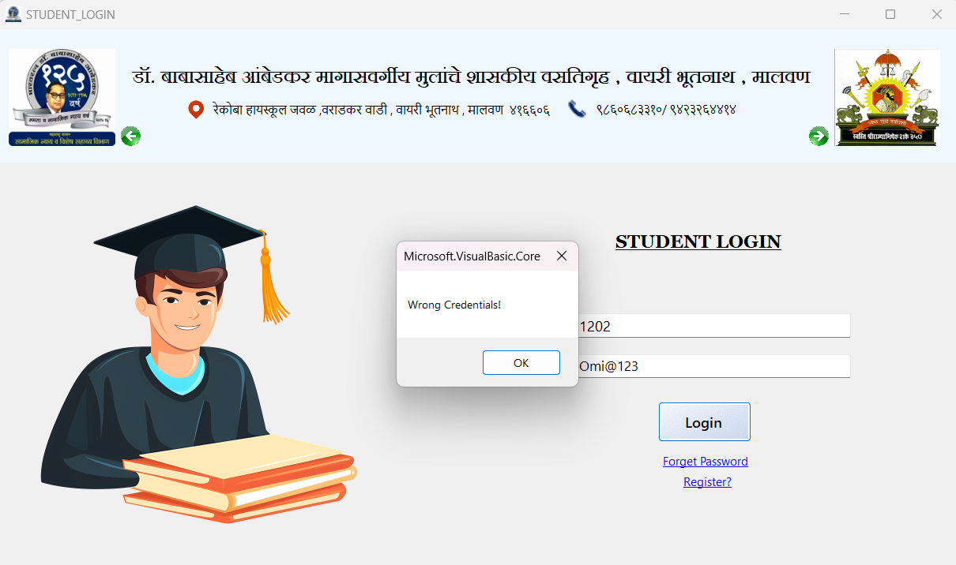

2.1 Login with Wrong Credentials

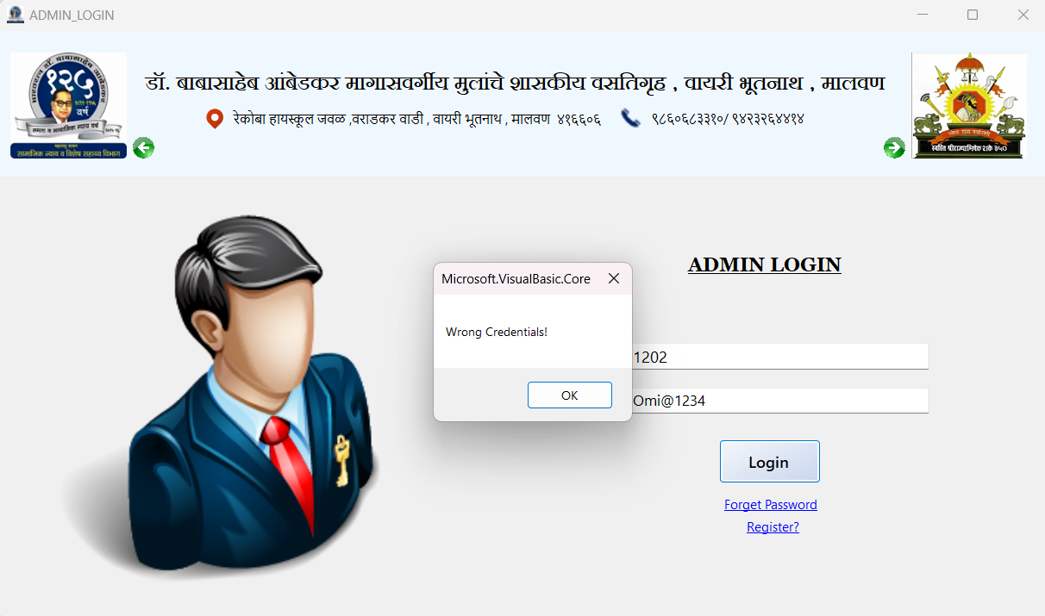

2.2 Login with Correct Credentials but with different Login